Lab Exercise - Azure Availability Zones with Load Balancer using Cloud Shell

Objective
In this lab you will:
- Create two VMs in different Availability Zones
- Install Apache Web Server
- Configure Azure Load Balancer
- Dynamically collect NIC and IP configuration details
- Test high availability across zones

Architecture
Internet
|
Azure Load Balancer
|
-------------------------
| |
VM1 (Zone 1) VM2 (Zone 2)
Apache Web Server Apache Web Server

Step 1: Login to Azure Cloud Shell
Open:
Azure Portal
Open Cloud Shell and select Bash.

Step 2: Define Variables
RESOURCE_GROUP="zone-lab-rg"
LOCATION="eastus"
VNET_NAME="zone-vnet"
SUBNET_NAME="zone-subnet"
VM1="zone-vm1"
VM2="zone-vm2"
LB_NAME="zone-lb"
USERNAME="azureuser"

Step 3: Create Resource Group
az group create \
--name $RESOURCE_GROUP \
--location $LOCATION

Step 4: Create Virtual Network
az network vnet create \
--resource-group $RESOURCE_GROUP \
--name $VNET_NAME \
--address-prefix 10.0.0.0/16 \
--subnet-name $SUBNET_NAME \
--subnet-prefix 10.0.1.0/24

Step 5: Create Public IP for Load Balancer
az network public-ip create \
--resource-group $RESOURCE_GROUP \
--name zone-lb-ip \
--sku Standard

Step 6: Create Standard Load Balancer
az network lb create \
--resource-group $RESOURCE_GROUP \
--name $LB_NAME \
--sku Standard \
--public-ip-address zone-lb-ip \
--frontend-ip-name myFrontEnd \
--backend-pool-name myBackEndPool

Step 7: Create VM in Zone 1
az vm create \
--resource-group $RESOURCE_GROUP \
--name $VM1 \
--image Canonical:0001-com-ubuntu-server-focal:20_04-lts-gen2:latest \
--zone 1 \
--vnet-name $VNET_NAME \
--subnet $SUBNET_NAME \
--size Standard_B1s \
--storage-sku Standard_LRS \
--admin-username $USERNAME \
--generate-ssh-keys

Step 8: Create VM in Zone 2
az vm create \
--resource-group $RESOURCE_GROUP \
--name $VM2 \
--image Canonical:0001-com-ubuntu-server-focal:20_04-lts-gen2:latest \
--zone 2 \
--vnet-name $VNET_NAME \
--subnet $SUBNET_NAME \
--size Standard_B1s \
--storage-sku Standard_LRS \
--admin-username $USERNAME \
--generate-ssh-keys

Step 9: Open Port 80 on Both VMs
VM1
az vm open-port \
--resource-group $RESOURCE_GROUP \
--name $VM1 \
--port 80 \
--priority 1010

VM2
az vm open-port \
--resource-group $RESOURCE_GROUP \
--name $VM2 \
--port 80 \
--priority 1020

Step 10: Install Apache on VM1
az vm run-command invoke \
--resource-group $RESOURCE_GROUP \
--name $VM1 \
--command-id RunShellScript \
--scripts "
sudo apt update
sudo apt install -y apache2
echo '<h1>Welcome from Zone 1 VM</h1>' | sudo tee /var/www/html/index.html
sudo systemctl restart apache2
"

Step 11: Install Apache on VM2
az vm run-command invoke \
--resource-group $RESOURCE_GROUP \
--name $VM2 \
--command-id RunShellScript \
--scripts "
sudo apt update
sudo apt install -y apache2
echo '<h1>Welcome from Zone 2 VM</h1>' | sudo tee /var/www/html/index.html
sudo systemctl restart apache2
"

Step 12: Dynamically Collect NIC Names
VM1 NIC
NIC1=$(az network nic list \
--resource-group $RESOURCE_GROUP \
--query "[0].name" \
-o tsv)
echo $NIC1

VM2 NIC
NIC2=$(az network nic list \
--resource-group $RESOURCE_GROUP \
--query "[1].name" \
-o tsv)
echo $NIC2

Step 13: Dynamically Collect IP Configuration Names
VM1 IP Config
IPCONFIG1=$(az network nic ip-config list \
--resource-group $RESOURCE_GROUP \
--nic-name $NIC1 \
--query "[0].name" \
-o tsv)
echo $IPCONFIG1

VM2 IP Config
IPCONFIG2=$(az network nic ip-config list \
--resource-group $RESOURCE_GROUP \
--nic-name $NIC2 \
--query "[0].name" \
-o tsv)
echo $IPCONFIG2

Step 14: Add VMs to Backend Pool
Add VM1
az network nic ip-config address-pool add \
--address-pool myBackEndPool \
--ip-config-name $IPCONFIG1 \
--nic-name $NIC1 \
--resource-group $RESOURCE_GROUP \
--lb-name $LB_NAME
Add VM2
az network nic ip-config address-pool add \
--address-pool myBackEndPool \
--ip-config-name $IPCONFIG2 \
--nic-name $NIC2 \
--resource-group $RESOURCE_GROUP \
--lb-name $LB_NAME

Step 15: Create Health Probe
az network lb probe create \
--resource-group $RESOURCE_GROUP \
--lb-name $LB_NAME \
--name httpProbe \
--protocol tcp \
--port 80

Step 16: Create Load Balancer Rule
az network lb rule create \
--resource-group $RESOURCE_GROUP \
--lb-name $LB_NAME \
--name httpRule \
--protocol tcp \
--frontend-port 80 \
--backend-port 80 \
--frontend-ip-name myFrontEnd \
--backend-pool-name myBackEndPool \
--probe-name httpProbe

Step 17: Get Load Balancer Public IP
az network public-ip show \
--resource-group $RESOURCE_GROUP \
--name zone-lb-ip \
--query ipAddress \
-o tsv

Example Output:
40.114.35.47

Step 18: Test Load Balancer
Open browser:
http://<LOAD_BALANCER_PUBLIC_IP>
Refresh multiple times.
You should see:
Welcome from Zone 1 VM
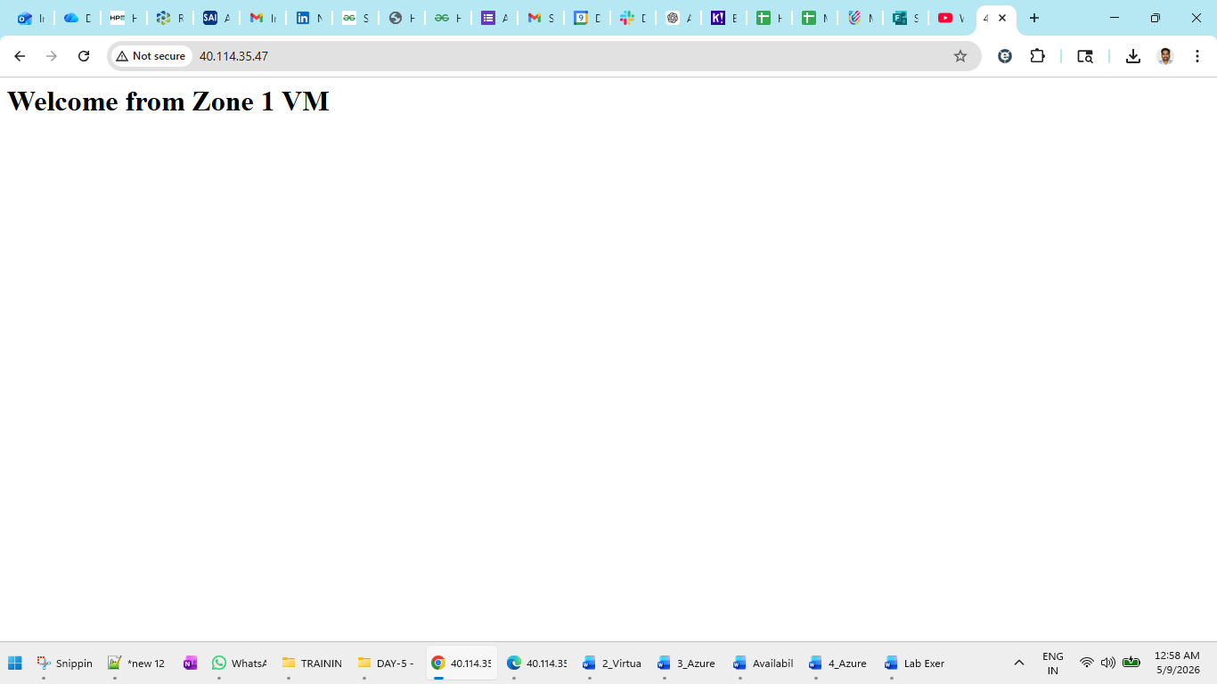
and sometimes:
Welcome from Zone 2 VM
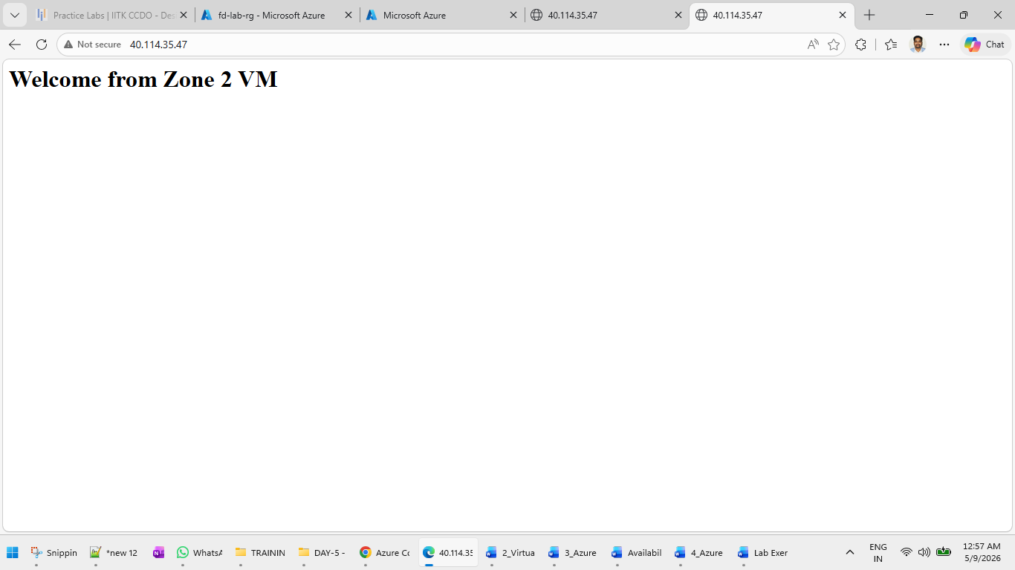

Step 19: Simulate Zone Failure
Stop VM1:
az vm stop \
--resource-group $RESOURCE_GROUP \
--name $VM1

Refresh browser again.
Traffic should automatically go to:
Welcome from Zone 2 VM
This demonstrates high availability using Availability Zones.

Verification Commands
Check Backend Pool Association
az network nic ip-config show \
--resource-group $RESOURCE_GROUP \
--nic-name $NIC1 \
--name $IPCONFIG1

Check Load Balancer Rule
az network lb rule list \
--resource-group $RESOURCE_GROUP \
--lb-name $LB_NAME \
-o table

Cleanup Resources
az group delete \
--name $RESOURCE_GROUP \
--yes \
--no-wait

Expected Learning Outcome
After completing this lab, you will understand:
- What Availability Zones are
- How Azure provides high availability
- How to deploy zonal VMs
- How Azure Load Balancer distributes traffic
- How health probes work
- How failover happens automatically between zones

